

**True Finance – Ten years after the financial crisis**

Speech given by Mark Carney

Governor of the Bank of England Chair of the Financial Stability Board

Economic Club of New York 19 October 2018

I am grateful to Alice Carr, James Benford and Clare Macallan for their assistance in preparing these remarks, and to Paul Brione, Chris Ford, Alex Michie, Harry Jackson and David Nicholls for background research and analysis.

1

# INTRO

Last week, global financial policymakers gathered in Bali for the Annual Meetings of the IMF and World Bank.

These meetings came a decade after the global financial crisis, two decades after the Asian crisis, and three decades after the Latin American debt crisis. Anyone spot a pattern?

Despite the past decade of financial reform, many are asking whether anything has really changed.

I am going to argue today that such weary fatalism is at odds with reality. That the radical programme of G20 reforms has made the global financial system safer, simpler and fairer. That these measures are creating a system that can serve households and businesses in bad times as well as good. That true change is creating true finance, a system that can deepen financial inclusion, better meet the needs of ageing populations and help fund the transition to a low carbon economy.

But I will also caution that we will forfeit these gains if we once again fall under the spell of the three lies of finance that helped cause the global financial crisis. To resist their siren calls, we must maintain the new institutional frameworks created in its wake.

Globally, the most important of these is the Financial Stability Board (FSB). Having agreed all the major international reforms to address the causes of the crisis, the FSB is now pivoting to focus on their timely, effective and consistent implementation. Mindful of history, the FSB is also scanning the horizon to identify and address new vulnerabilities that emerge as the structure of our economies and financial systems change.

We know we cannot rest on our laurels. Financial history rhymes all too frequently, with enormous costs to our citizens. We must remain vigilant, resist the three lies of finance, and reinforce some core financial truths.

# THE THREE LIES OF FINANCE

**“This Time Is Different”**

The first lie of finance is the four most expensive words in the English language: “This Time Is Different.”1

This misconception is usually the product of an initial success, with early progress gradually building into a blind faith in a new era of effortless prosperity.

It took a revolution in macroeconomic policy to help win the battles against the high and unstable inflation, rising unemployment and volatile growth of the 1970s and 1980s.

1 For an extensive survey, see Reinhart, C and Rogoff, R, (2009), *This time is different: eight centuries of financial folly*, Princeton University Press.

accountable and highly effective.

Clear remits. Parliamentary accountability. Sound governance. Independent, transparent and effective policy-making. These were the great successes of that time and their value endures today.

But these innovations did not deliver lasting macroeconomic stability. Far from it.

Price stability was no guarantee of financial stability. An initially healthy focus would become a dangerous distraction. Against the serene backdrop of the so-called Great Moderation (**Chart 1**), a storm was brewing as total non-financial debt in the G7 rose by the size of its GDP (**Chart 2**).

Several factors drove this debt super-cycle including demographics and the stagnation of middle-class real wages (itself the product of technology and globalisation). In the US, households had to borrow to increase consumption. “Let them eat cake” became “let them eat credit”.2

Financial innovation made it easier to do so. And the ready supply of foreign capital made it cheaper.

Most importantly – and this is the lie – complacency among individuals and institutions, fed by a long period of macroeconomic stability and rising asset prices, made this remorseless borrowing seem sensible.3

When the crisis broke, policymakers quickly dropped the received wisdoms of the Great Moderation and scrambled to re-learn the lessons of the Great Depression.4 Minsky became mainstream.5

# Lie II: “Markets Always Clear”

A deep-seated faith in markets lay beneath the new era thinking of the Great Moderation. Captured by the myth that finance can regulate and correct itself spontaneously, authorities retreated from their regulatory and supervisory responsibilities.6

The second lie, the belief that “markets always clear,” has two dangerous consequences.7

First, if markets always clear, they can be assumed to be in equilibrium— or said differently “to be always right”. If markets are efficient, then bubbles can neither be identified nor can their potential causes be

2 Raghuram Rajan (2010), “Fault Lines: How Hidden Fractures Still Threaten the World Economy”.

3 This emphasis on the endogenous tendency of financial systems to become unstable is reminiscent of Hyman Minsky’s “financial instability hypothesis” (Minsky (1992)).

4 See for example, Krugman, P, (1999, updated and reissued 2008), *The Return of Depression Economics and the crisis of 2008*,

Penguin.

5 Indeed, in a July 2016 article, The Economist noted that Minksy had been referred to only once in their publication during his working life from the 1950s through to 1996 when he died, but that he had been mentioned around 30 times since the crisis broke in 2007.

6 For a review of this broader phenomenon, see Padoa-Schioppa, T (2010), “Markets and government before, during and after the 2007- 20xx crisis”, The Per Jacobsson Lecture, June.

7 See also Turner, A (2010), “Market efficiency and rationality: why financial markets are different”, Lionel Robbins Memorial Lectures,

London School of Economics.

crisis.8

Second, if markets always clear, they should possess a natural stability. Evidence to the contrary must be the product of either market distortions or incomplete markets.

Much of financial innovation springs from the logic that the solution to market failures is to build new markets on old ones.9 Progress through infinite regress.

During the Great Moderation, this view became an organising principle for financiers and policymakers. The latter pursued a light touch regulatory agenda in quest for a perfect real world of complete markets first described as abstract theory by Arrow and Debreu.10

Of course, markets only clear in textbooks. In reality, people are irrational, economies are imperfect, and nature itself is unknowable.

When such imperfections exist, adding markets can sometimes make things worse.

Take synthetic credit derivatives, which were supposed to complete a market in default risk and thereby improve the pricing and allocation of capital.

Financial alchemy appeared to have distributed risk, parcelling it up and allocating it to those who wanted most to bear it.11

However, the pre-crisis system had only spread risk, contingently and opaquely, in ways that ended up increasing it. Once the crisis began, risk quickly concentrated on the balance sheets of intermediaries that were themselves capital constrained. And with the fates of borrowers and lenders tied together via hyper- globalised banks and markets, problems at the core spread violently to the periphery.

A truth of finance is that the riskiness of an asset depends on who owns it. When markets don’t clear, agents may be surprised to find what they own and for how long. When those surprises are – *or are thought to be* – widespread, panic ensues (**Chart 3**).

8 Such naïveté is striking given that evidence of disequilibria abounds in markets for goods and labour. In goods markets, there is ‘sluggishness everywhere’. Left to themselves, economies can go for sustained periods operating above or below potential, resulting, ultimately, in excessive or deficient inflation. Yet efficient market forces ‘should’ bring about changes in prices sufficient to equate demand with potential, leaving inflation as a purely monetary phenomenon. In labour markets, there is ‘rigidity everywhere’. Rather than fluidly adjusting to equate the demand for labour with its supply, periods of deficient labour demand can persist, sustaining mass unemployment and joblessness. Yet efficient market forces ‘should’ eliminate these disequilibria by having wages adjust to ensure full employment always and forever. Monetary Policy is not only a response to these rigidities; it is made effective by them.

9 But economists of a more nuanced persuasion pointed out as far back as the 1950s that this logic is flawed. See Lipsey, R and Lancaster, K (1956), “The general theory of the second best”, Review of Economic Studies, 24(1).

10 Their world imagines self-interested, atomistic agents, coolly calculating odds over all future possible states of the world, writing and trading contracts with each other, all frictionlessly enforced, all achieving mutually beneficial – indeed socially optimal – outcomes.

Arrow, K and Debreu, (1954), “Existence of an equilibrium for a competitive economy”, Econometrica, 22 (3).

11 The bankers who played a leading role in developing the credit derivatives market declared “Credit derivatives are a mechanism for

transferring risk efficiently around the system” and that defaulted loans that would have knocked a hole in a bank’s balance sheet ten years ago were “now hits that we have spread around the system, and represent tiny blips on the balance sheet of hundreds of financial institutions”, see p99, Tett, G., “Fool’s Gold”, (2009).

Even if markets could be perfected, nature itself is unknowable.12

That is genuine uncertainty, as opposed to risk, the distinction made by Frank Knight in the 1920s.13 And it means that market outcomes reflect individual choices made under a pretence of knowledge.14

The swings in sentiment that result – pessimism one moment, exuberance the next – do not reflect nature’s odds, but our own assessments of them, inevitably distorted by Keynes’ optimistic “animal spirits” and his cynical “beauty contests”.15

These are dynamics that can afflict not just sophisticated investors, but mortgage lenders and homebuyers, especially during a “new era”.

If house prices can only go up, it is possible to borrow large multiples and pay off future obligations with the capital gains that will follow.

Such “rational” behaviour fuelled the credit binge that ultimately led to the global crisis.

In the end, belief that “markets are always right” meant that policymakers didn’t play their proper roles moderating those tendencies in pursuit of the collective good.

# Lie III: “Markets Are Moral”

The third lie, that markets are always moral, takes for granted the social capital that markets need to fulfil their promise.16

The crisis showed that if left unattended, markets can be prone to excess and abuse.

In financial markets, means and ends can be conflated too easily. Value can become abstract and relative. And the pull of the crowd can overwhelm the integrity of the individual.

Consider the example of fixed income, currencies and commodities (FICC) markets, which have historically relied heavily on informal codes and understandings.17

12 Recall that the Arrow-Debreu world relies on people being able to calculate the odds of each and every possible scenario. Then they can trade contracts and insure each other against risks they are unwilling to bear. Even a moment of introspection reveals the absurdity of these assumptions as a description of the actual world. More often than not, even describing the universe of possible outcomes is beyond the means of mere mortals, let alone ascribing subjective probabilities to those outcomes.

13 Knight, F (1921), Risk, uncertainty and profit, Signalman Publishing.

14 FA Hayek Nobel prize speech 1974 “The pretence of knowledge”.

15 In Keynes (1936), Chapter 12, he wrote: “Even apart from the instability due to speculation, there is the instability due to the characteristic of human nature that a large proportion of our positive activities depend on spontaneous optimism rather than on a

mathematical expectation, whether moral or hedonistic or economic. Most, probably, of our decisions to do something positive, the full consequences of which will be drawn out over many days to come, can only be taken as a result of animal spirits – of a spontaneous urge to action rather than inaction, and not as the outcome of a weighted average of quantitative benefits multiplied by quantitative probabilities.” Keynes, J M (1936), *The General Theory of Interest, Employment and Money*, Palgrave Macmillan.

16 Carney (2014), Inclusive capitalism: creating a sense of the systemic.

17 They have also, over the centuries, been beset by poor behaviour, as shown by the FMSB’s comprehensive review of misconduct over the past two centuries. The history of financial fraud has rhymed all too frequently. See FMSB Annual Report (2017).

licence that markets need to innovate and grow.18

Rather than being professional and open, markets became informal and clubby. Rather than competing on merit, participants colluded online. Rather than everyone taking responsibility for their actions, few were held to account.

The crisis reminded us that real markets don’t just happen; they depend on the quality of market infrastructure for their effectiveness, resilience and fairness.

Robust market infrastructure is a public good in constant danger of under-provision, not least because the best markets innovate continually. This risk can only be overcome if all market actors, public and private, recognise their responsibilities for the system as a whole.

# TRUE FINANCE

So this time is no different. Markets don’t always clear. And we can suffer from their amorality. What to do with such knowledge? And how to retain it?

To resist the siren calls of the three lies of finance, policymakers and market participants must bind themselves to the mast. That means building institutional frameworks that make it easier to resist as the lies regain their seductive power. If we can, we will build True Finance, an enduring platform for strong, sustainable and balanced growth.

Over the past decade, great strides have been made.

Let me begin with the global reforms that have addressed the third lie that “markets are moral”.

In the cycle of scandal, response, integrity, drift, and new scandal, potential solutions have oscillated between the extremes of Light Touch Regulation and Total Regulation.

There are problems with each.

By undervaluing the importance of hard and soft infrastructure to the functioning of real markets, light touch regulation led directly to the financial crisis.19

18 The scale of misconduct impaired banks’ ability to function fairly and effectively. Global banks’ misconduct costs have exceeded $320 billion, capital that could otherwise have supported around $5 trillion of lending to households and businesses. More worrying still, in a system where trust is fundamental, it ought to be of grave concern that only 20% of UK citizens now think that banks are well run, compared to 90% in the 1980s.

19 “Hard infrastructure” refers to the way in which markets are organised. “Soft infrastructure” refers to the standards and norms, including regulation, market standards and codes, by which markets operate.

neither felt responsible for the system nor recognised the full impact of their actions. Bad behaviour went unchecked, proliferated and eventually became the norm.

Yet a system reliant on total regulation and large ex post sanctions is similarly bound to fail because it promotes a culture of complying with the letter of the law, not its spirit, and because authorities will inevitably lag developments in fast-changing markets.

A more comprehensive and lasting solution combines public regulation with private standards and then buttresses both with incentives to increase materially the understanding and accountability of individuals.

In the UK, new laws and regulations are doing just that.20 Compensation rules now align risk and reward, with a significant proportion of variable compensation deferred for up to seven years across the banking industry. Regulatory references mean that the histories of those with a record of misconduct will be known to anyone considering hiring them.21

Authorities have also used their convening powers to encourage market participants to develop standards of market practice, such as the new Global FX Code and the FMSB standards for FICC markets.22 23

The UK Senior Managers' Regime (SMR) gives teeth to voluntary codes by incentivising firms to embed them and by re-establishing the link between seniority and accountability.24 Under the SMR, the most senior decision-makers of banks, insurers and major investment firms can now be held individually accountable if they fail to take reasonable steps (including training or proper oversight) to prevent regulatory breaches in their areas of responsibility.

The FSB has identified a similar menu of tools under its Misconduct Action Plan, which its members can draw from. Thus far, however, action to promote good conduct has varied widely across the G20.25

The FSB’s compensation standards have been written into G20 regulatory rules, but not yet fully deployed.26 Although adjusting in-year pay is common, clawing back bonuses later on is not, even though it typically takes several years for evidence of misconduct to emerge. And few jurisdictions have put in place either formal mechanisms to ensure that boards and senior managers are explicitly responsible and accountable for what happens at their regulated firms or regulatory references to stop those with poor conduct records moving from firm to firm.

20 Fair and Effective Markets Review Final Report, HM Treasury, Bank of England and FCA (June 2015). 21 PRA Supervisory Statement | SS28/15 Strengthening individual accountability in banking, May 2017. 22 FX Global Code (2018).

23 FMSB stands for Fixed Income, Currencies and Commodities Markets Standards Board. See Carney (2017), Turning back the tide.

24 Allen, T., (Q3 2018), Strengthening the link between seniority and accountability: the Senior Managers and Certification Regime, Bank of England Quarterly Bulletin

25 FSB (April 2018), [Strengthening Governance Frameworks to Mitigate Misconduct Risk: A Toolkit for Firms and Supervisors.](http://www.fsb.org/2018/04/strengthening-governance-frameworks-to-mitigate-misconduct-risk-a-toolkit-for-firms-and-supervisors/)

26 FSB, (2017), Implementing the Principles for Sound Compensation Practices and their Implementation Standards, Fifth Progress Report.

periodically undermines market integrity and impairs finance’s ability to function effectively.27

And most fundamentally, without greater individual responsibility, it is hard to see how social capital can be fully regained.

********

The recognition that “markets don’t always clear” has spurred major reforms to make markets less complex and more robust.

A decade ago, OTC derivative trades were largely unregulated, unreported and bilaterally settled. When Lehman fell, uncertainty about such exposures sparked panic.

Since then, the FSB has designed a series of reforms to make these markets safer and more transparent, including by requiring trade reporting and by encouraging central clearing of over-the-counter (OTC) trades.

These reforms are having their desired effects. Supervisory authorities and market participants can now readily monitor activity and exposures. 90% of new OTC single-currency interest rate derivatives are now centrally cleared in the US. And an additional $1 trillion of collateral is now held globally against all derivative trades.

Central counterparties (CCPs) reduce systemic risk, provided they meet the highest standards of resilience, recoverability and resolvability. That is why G20 reforms have significantly increased the standards to which CCPs are held, ranging from higher margins and liquidity to better operational and cyber resilience.28 To finalise its policy work, the FSB will report to G20 Leaders next month on the need for guidance on CCP financial resources in resolution.29

Now is the time for FSB members to address any gaps in their supervisory and resolution frameworks for CCPs. For example, some authorities do not yet have all of the resolution powers expected under FSB standards. And it’s time for the FSB (in conjunction with CPMI-IOSCO) to assess whether, when taken together, reforms to resilience, recoverability and resolvability are sufficient and are working as intended.

A decade on from the financial crisis, a series of measures are eliminating the fragile forms of shadow banking while reinforcing the best of resilient non-bank financial intermediation. The toxic forms of shadow banking at the heart of the crisis – with their large funding mismatches, high leverage and opaque, off- balance-sheet arrangements – no longer represent a global stability risk (**Chart 4**).

And other, more constructive forms of non-bank finance, including money market funds and repo markets, are subject to new policy measures that reduce their risks and reinforce their benefits.

27 See FMSB Annual Report (2017) for examples of misconduct over two centuries.

28 See CMPI-IOSCO’s Principles for Financial Market Infrastructure (PFMI).

29 FSB Chair’s Letter to G20 Finance Ministers and Central Bank Governors, March 2018.

economies.

For example, while China’s economic miracle over the past three decades has been extraordinary, its post- crisis performance has increasingly relied on a large build-up of debt and an associated explosion of shadow banking (**Chart 5**).

The non-bank finance sector has increased from around 10% of GDP a decade ago to over 100% now, with developments echoing those in the pre-crisis US such as off-balance sheet vehicles with large maturity mismatches, sharp increases in repo financing, and large contingent liabilities of borrowers and banks.

The Chinese authorities recognise that “this time may not be different” and have begun taking measures to manage the risks.30

More broadly, a potentially major new vulnerability has emerged across the G20.

This risk starts, as is often the case, with a positive development. Global assets under management have grown from around $50 trillion a decade ago to $80 trillion in 2017,31 and have accounted for all the increase in foreign lending to EMEs since the crisis.

This is bringing welcome diversity to the financial system.

At present, however, asset management’s growing importance could increase the risks of sudden stops and feed more intense capital flow reversals from emerging markets. That is because more than $30 trillion of assets are held in funds that promise daily liquidity to investors despite investing in potentially illiquid underlying assets.32

In other words, they are built on the lie that markets always clear.

To assess the risks of fire sales and contagion across emerging and credit markets, authorities need to gather and share data on asset management. In this context, the FSB expects that consistent and decision- useful measures of leverage will be developed to support an effective global risk assessment. I would encourage industry to engage with the upcoming IOSCO consultation on this issue.

The FSB is also refining its Systemic Stress Initiative to explore how funds and other non-bank financial institutions might collectively act in ways that amplify shocks.33

30 IMF Article IV Consultation for the People’s Republic of China (2018).

31 See Boston Consulting Group estimate of global AUM in Global Asset Management 2018.

32 See FSB Global Shadow Banking Monitoring Report (2017).

33 The Bank of England is working to better understand such dynamics as well. See Baranova, Y., Coen, J., Lowe, P., Noss, J., and Silvestri, L. “Simulating stress across the financial system: the resilience of corporate bond markets and the role of investment funds”,

*Bank of England Financial Stability Paper*, (2017).

structural vulnerabilities associated with asset management.34 Authorities and firms must implement the FSB’s recommendations for greater consistency between funds’ redemption terms and their assets and investment strategies. Funds should have the liquidity management tools to deal with stressed conditions. And these tools must be able to dampen the impact of first mover advantage on systemic risk.

Given the scale and proximity of the potential risks, in the Bank of England’s view, authorities should review the adequacy both of its recommendations and their implementation sooner rather than later.35

Policymakers must be alert situations where market innovation once again introduces complexity and opacity, and excessive reliance on markets always clearing.

For example, global leveraged lending is growing at rates – and has reached a scale – comparable to the subprime on the eve of the crisis.36 Underwriting criteria have loosened as rapidly,37 the requirement that managers retain a portion of their securitisations has been overturned by U.S. courts, and there is limited information on the ability of the ultimate holders of the debt to absorb losses.

To be clear, there are important differences between leveraged lending and sub-prime. In particular, the banks at core of the system are significantly more resilient and have limited direct or indirect exposures.

But recall that the last two vintages of subprime pre-crisis were twice as likely to default as their predecessors, and that the leveraged loan market shows few signs of slowing.

******************** Turning finally to the lie that “This Time is Different”.

If the experience of the financial crisis teaches us anything, it’s humility. We cannot anticipate every risk or plan for every contingency. But we can, and must, plan for failure. That is how we can create an anti-fragile system that is robust to both the intensification of known risks and the crystallisation of Rumsfeldian unknowns.

*An anti-fragile system requires resilient banks.*

A decade ago, major banks were woefully undercapitalised, with complex business models that relied on the goodwill of markets and, ultimately, taxpayers.

Large global banks can now stand on their own.

34 See FSB Policy Recommendations to Address Structural Vulnerabilities from Asset Management Activities (2017).

35 FPC record (Q3 2018).

36 Over the past year, leveraged lending has grown by around 15% (or 10% of total advanced economy credit to corporates) as compared with an estimated 13% growth (or 13% of the total share of US mortgages), for the sub-prime market to 2007.

37 With maintenance covenants falling from close to 100% in 2010 to around 20% now.

protect the system from risks we think are low but prove not, banks are subject to a simple, minimum leverage ratio, which is robust to model risk.

Regulation has made banks less complex and more focused. Business strategies that relied on high leverage, risky trading activities and wholesale funding are disappearing, as intended. Trading assets have been cut in half, and interbank lending is down by one-third.38

Not least due to new global liquidity standards, banks have changed their funding models and now hold substantially more liquid assets relative to the liabilities that can readily run. In the UK, such contingent liquidity has increased tenfold since the crisis.

*An anti-fragile system requires ending Too Big to Fail.*

But higher capital and liquidity requirements are necessary but not sufficient. Banks must also be able to fail without systemic consequences.

A decade ago, large complex banks operated in a “heads I win tails you lose” bubble. They privatised profits in the run-up to the crisis before socialising the losses when the music stopped.

The complete loss of confidence in private finance that crystallised in the autumn of 2008 could only be arrested by public support over the following year that totalled $15 trillion in bail-outs, government guarantees of bank liabilities and special central bank liquidity schemes.

To bring back the discipline of the market and end reliance on public funds, FSB members agreed standards to ensure that globally systemic banks (G-SIBs) can fail safely in the future.39

These banks have had to make themselves easier to resolve. They must now hold sufficient debt such that, in the event one fails, its successor can be recapitalised to support the continued operation of its most important activities.

The powers and tools authorities need to deal with failing banks have been fully implemented in the UK. Our major banks have ring-fenced their domestic activities. They already hold total loss-absorbing resources (or TLAC) of 25% of their risk-weighted assets, well within sight of their 2022 requirement of 28%.40

As a consequence, market discipline is back, with the public subsidy enjoyed by the UK’s largest banks having fallen by 90% (**Chart 6**).

38 Both as a proportion of the exposures of the 30 banks identified by the FSB as being G-SIBs.

39 FSB Key Attributes of Effective Resolution Regimes for Financial Institutions.

40 Across the G20 as a whole more than 80% of all G-SIBs already hold TLAC which meets the 2019 requirement of 16% and 60% already meet the 2022 requirement of 18% of risk-weighted assets (excluding capital buffers).

Given the importance of these reforms to both global financial stability and trust in the system, the FSB will undertake a thorough assessment of their effectiveness over the next year and report to G20 leaders. Key considerations will be the adequacy of the resolution plans, or Living Wills, whether G-SIBs will have sufficient liquidity in resolution, and whether it will be feasible – both in practical and political terms – to impose losses on the holders of TLAC in resolution.

*An anti-fragile system must be as robust to operational failures as to financial ones.*

While past crises had their roots in financial losses, in our digital era systemic shocks can also come from non-financial sources, including cyber-attacks.

To improve firms’ cyber defences, the largest banks and market infrastructure at the core of the UK financial system are subject to penetration tests (known as CBEST) and are required by their supervisors to address any deficiencies uncovered.

In parallel, we are literally planning for failure. In the UK, we have begun setting standards for how quickly critical financial institutions must be able to restore vital services following a successful cyber-attack. We will conduct cyber stress tests of firms’ ability to meet our impact tolerances in “severe but plausible” scenarios, and prescribe remedial action plans if they fail.

Internationally, we are working closely with the US Treasury as co-chairs of the G7 Cyber Expert Group to develop and disseminate best practice in information sharing, penetration testing and as of next year, cyber recovery.

*And an anti-fragile system requires a Comprehensive Macroprudential Framework.*

Macroprudential frameworks encourage authorities to meet the next challenge, not simply fight the last war. They prompt exploration of “what could happen?” not the false comfort of being ready for what is most likely to happen.41

Macroprudential authorities must consider the safety of the financial system as a whole. That requires both comprehensive and varied stress testing of the core as well as regular examination of the risks that may lie beyond the regulatory perimeter.

Macroprudential policy should be countercyclical, building resilience when risks are increasing and drawing on that resilience when risks crystallise. And it must address the macro-financial implications of major imbalances in the real economy, whether in housing markets or the balance of payments.

41 Alex Brazier ‘How to: Macropru’, 2017.

# BREXIT: Macroprudential policy in practice

Consider a topical example: the Bank of England’s macro-prudential approach to Brexit led by the Bank’s independent Financial Policy Committee (FPC).

When it comes to Brexit, the Bank of England does not focus on the most likely outcome, but rather the possible consequences of a disorderly, cliff-edge exit from the EU, however unlikely that may be.

In other words, we aren’t hoping for the best, we’re preparing for the worst in several ways. First, we’re ensuring that our banks are ready for Brexit.

In recent years we have subjected major UK banks to severe but plausible stress tests. In our 2017 stress test, UK GDP fell by 4.5%, commercial real estate prices by 40%. UK house prices dropped by a third, Bank Rate increased by 4 percentage points and unemployment rose to 9½%. In addition, there was a major emerging market shock and substantial additional misconduct costs. The FPC found that UK banks would have been able to withstand that stress and still have more than adequate capital to maintain lending to households and businesses (**Chart 7)**.

In the FPC’s judgment, our stress test last year also encompassed an appropriately wide range of UK macroeconomic risks and associated losses that could be associated with Brexit.

Moreover, we judge that the UK banking system has the capacity to absorb not only the consequences of a “no deal no transition” Brexit, but also the losses that could be associated with intensifying trade tensions, a further sharp tightening of financing conditions for emerging markets, and substantial additional misconduct costs.

Second, liquidity is an important part of our contingency planning for Brexit. UK-based banks (and CCPs) currently have around £300 billion of borrowing capacity at the Bank through collateral pre-positioned in our facilities. That broadly matches the Bank’s peak lending to the financial system during the crisis, and liquidity positions have improved significantly since then.

Third, the Bank takes a countercyclical approach. The UK deploys a Counter Cyclical Capital Buffer (CCyB) through which capital is accrued in the good times for release in the bad. Two years ago, amid heightened uncertainty following the Referendum, we cut the CCyB by £6 billion, releasing £150 billion of additional lending capacity. As the immediate uncertainty receded, we then required banks to rebuild it. Today their capital buffers are twice as high, meaning the FPC could unlock over £300 billion of lending capacity, if required.

Fourth, the FPC has identified the major cross-border risks to financial services that could arise in a cliff- edge Brexit.

The biggest risks relate to contract continuity. 16 million insurance policyholders in the UK and 38 million in the EEA have policies that firms might lose the permission to perform in a no deal scenario. Around £100 trillion of cross-border derivative contracts could be disrupted by the loss of the regulatory permissions required to service them and loss of recognitions for CCPs.

The Bank has been working with the relevant parties over the past two years to ensure they have contingency plans for the worst case scenario. In some cases, particularly in insurance, UK financial companies are restructuring so they can continue to serve their EU customers. If all current plans are delivered successfully, the number of EU policyholders at risk will fall to 9 million.

For risks that private financial institutions cannot self-solve, the UK Government is taking forward legislation that will allow UK households and businesses to access financial services provided by EU companies.

Where joint action is required, we have been working with the European Central Bank. There has been considerable progress in the UK to address these risks, but only limited progress in the EU. Timely action by EU authorities is needed to mitigate risks to financial stability, particularly those associated with derivative contracts and the transfer of personal data.

Throughout the Bank’s preparations for Brexit, we have been clear that we will maintain the traditions that have underpinned the UK position as a leading international financial centre. In particular, we will maintain current levels of resilience and our commitment to openness.

# CONCLUSION

800 years of economic history teaches us that financial crises occur roughly once a decade. A frequency that reflects in part the short institutional memories in finance.

Our citizens have not forgotten the last crisis. Certainly not in the UK where average real incomes are still below pre-crisis levels. Or here in the US where confidence in banks remains near historic lows.

The reforms of the past decade have put in place a new financial system that could, with time, regain people’s confidence.

However, the challenge for policymakers is that, when it comes to financial stability, success is an orphan. As memories fade, complacency sets in and pressure to compromise re-emerges.

We all bear heavy responsibilities to safeguard recent progress and address emerging vulnerabilities.

Safeguarding progress does not mean defending all aspects of reform at all costs. The FSB is now assessing what is working as intended and addressing any inefficiencies or unintended consequences. The results of its first two evaluations – on the interaction of derivatives reforms and bank capital measures as

well as the impact of G20 reforms on financing of infrastructure investment – will be reported to G20 Leaders in Buenos Aires next month.

We need to tailor not taper. It is critical that the process of evaluation and adjustment does not compromise overall system resilience.

Addressing emerging vulnerabilities means having the foresight to anticipate new risks from cyber to CCPs, from accountability to asset management. And it means having the discipline to build an anti-fragile system that is robust to the risks we do not anticipate.

We will not abolish crises (which have their roots in changes to the real economy and irreducible uncertainty). But we can reduce their frequency and lessen their impact.

By resisting the three lies of finance and by voicing truths seldom told, we can build True Finance to better serve our citizens in bad times as well as good.

# Chart 1: The Great Moderation in the United Kingdom

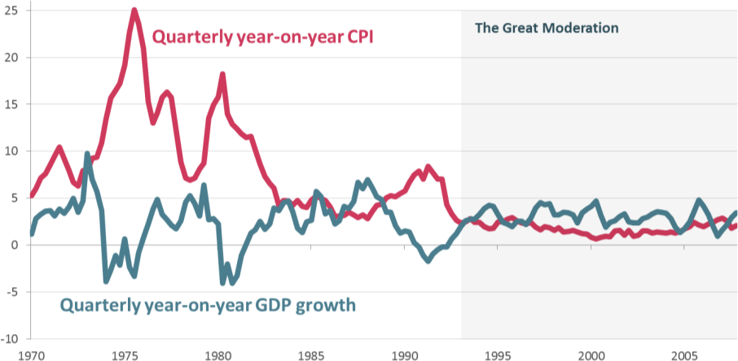

**Chart 2: G7 debt increased before the financial crisis**

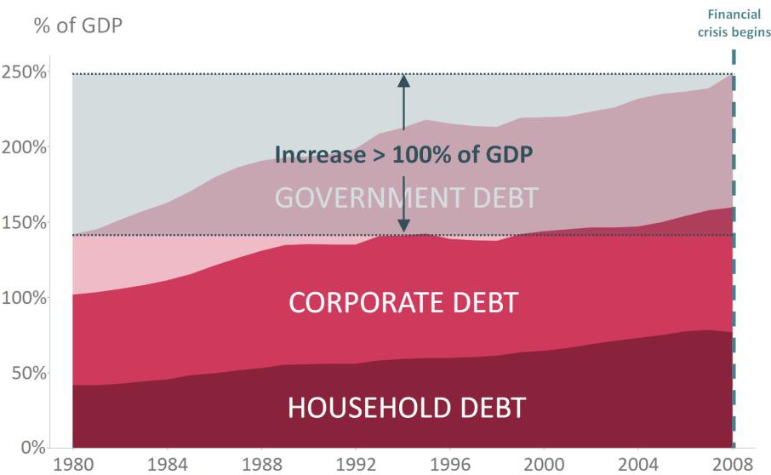

Source: IMF data and Bank calculations

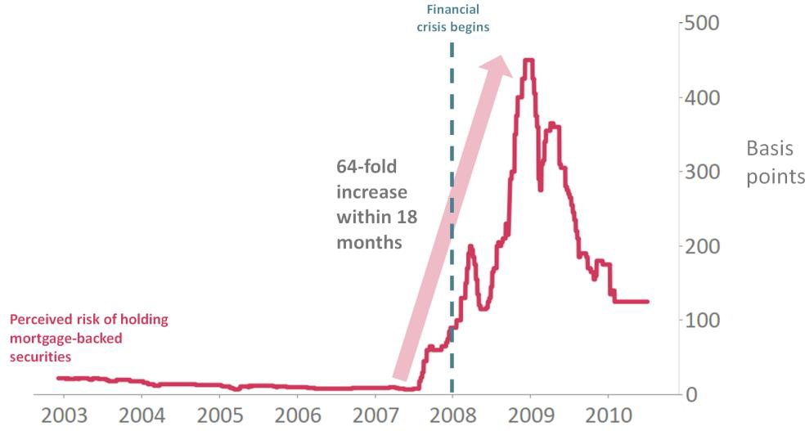

Source: UK AAA-rated residential mortgage-backed securities – 5 years spread to swap

# Chart 4: Shadow banking has transformed into resilient market-based finance

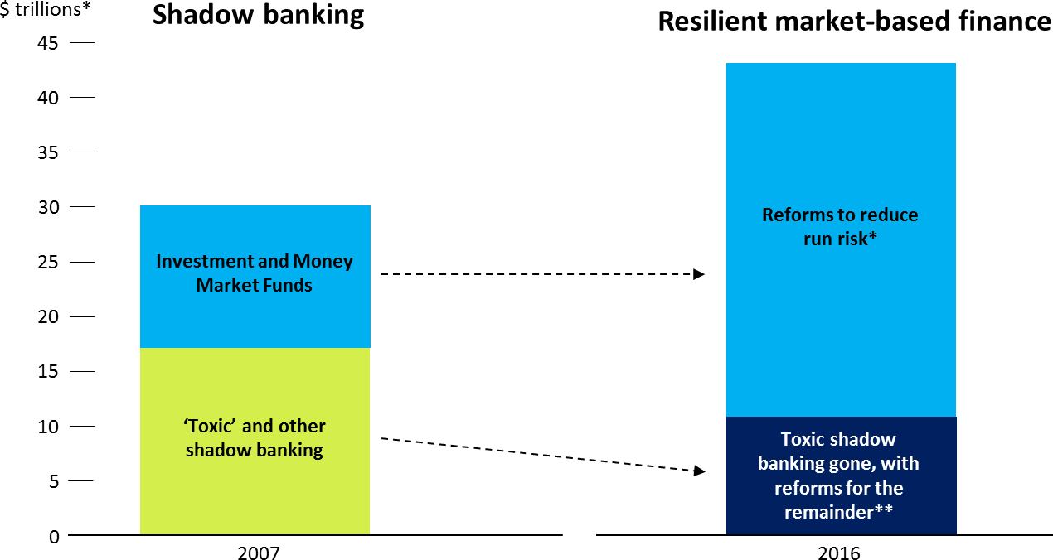

Source: FSB Global Shadow Banking Monitoring Report

* FSB asset management recommendations and MMF reforms (notably EU, US)

** Securitisation reforms, Market intermediation reforms

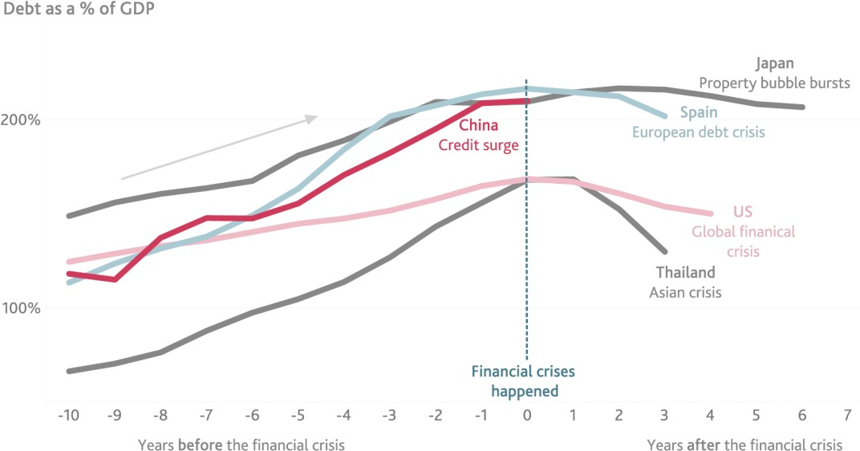

Source: BIS data and Bank of England calculations

# Chart 6: Markets no longer rely on government support

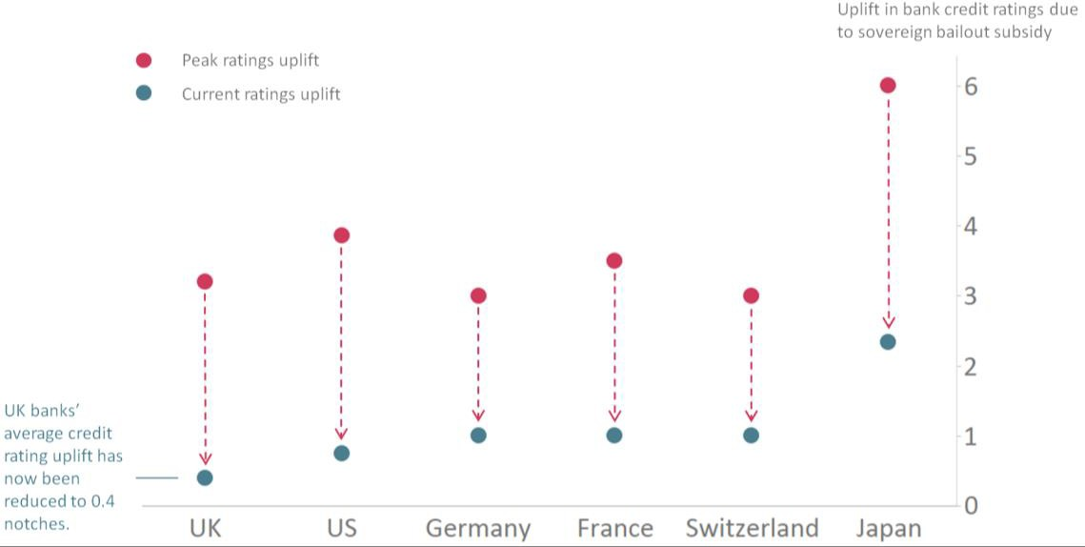

Source: Moodys and Bank calculations

# and a market crash

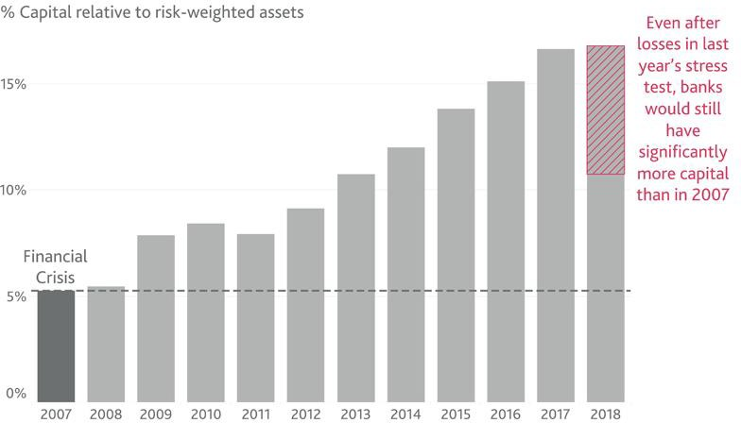

19